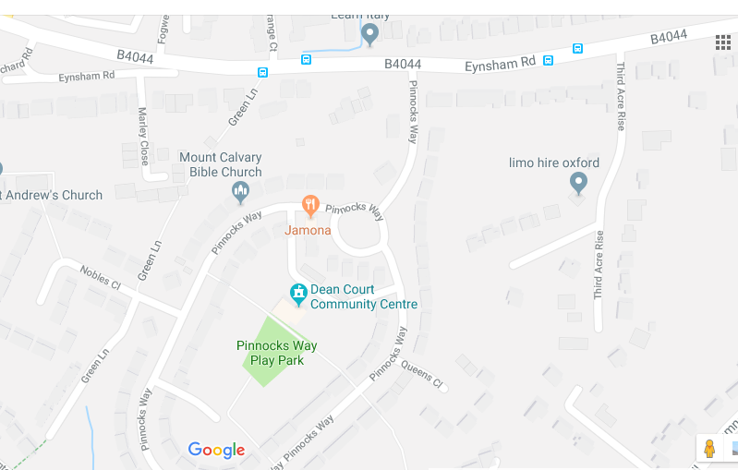

If driving, from the Botley shops, turn down the Eynsham Road (B4044) towards Farmoor, take the third left turn on to Pinnocks Way, take the left-hand fork, continuing past Pinnocks Green on your right, then take the small access road to your right. Continue for 100 yards and the Community Centre will be on your left.

The S1 bus runs from George Street along the Eynsham Road, with Third Acre Rise the closest stop – Pinnocks Way should be the first left turn after Third Acre Rise.